**Active directory using LDAP for login application in Java**

**1.Steps to Create Active Directory**

1)You should have administrator access.

2)  Then open the server manager. Go to PowerShell (as administrator) and type **ServerManager.exe** and press enter.

3) Then on server manager click on add roles and features

[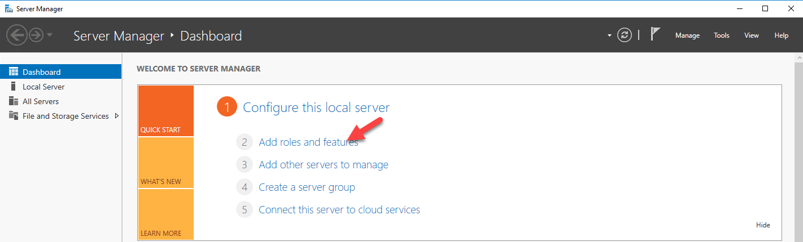](http://www.rebeladmin.com/wp-content/uploads/2016/10/2016AD3.png)

4) Then it opens the add roles and features wizard. Click on **next** to proceed.

[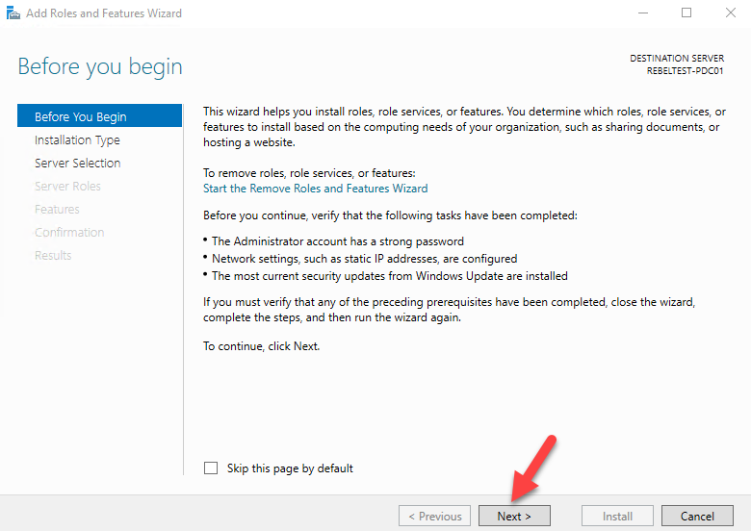](http://www.rebeladmin.com/wp-content/uploads/2016/10/2016AD4.png)

5) Then in next window keep the default and click **next**

[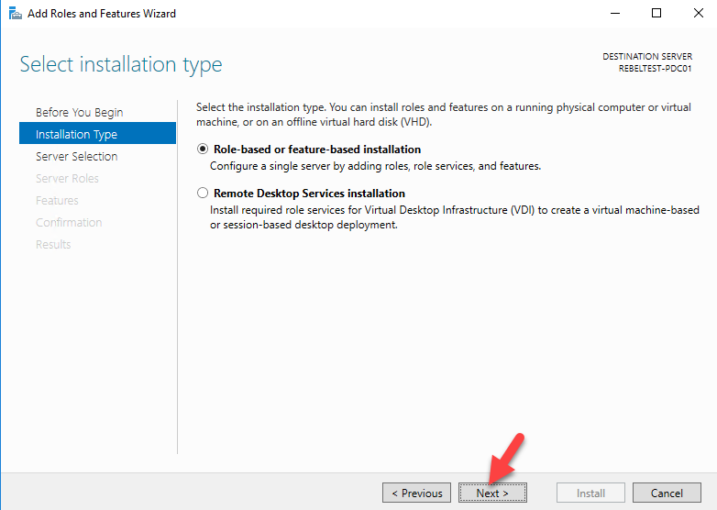](http://www.rebeladmin.com/wp-content/uploads/2016/10/2016AD5.png)

6) Since its going to be local server, in next window keep the default selection.

[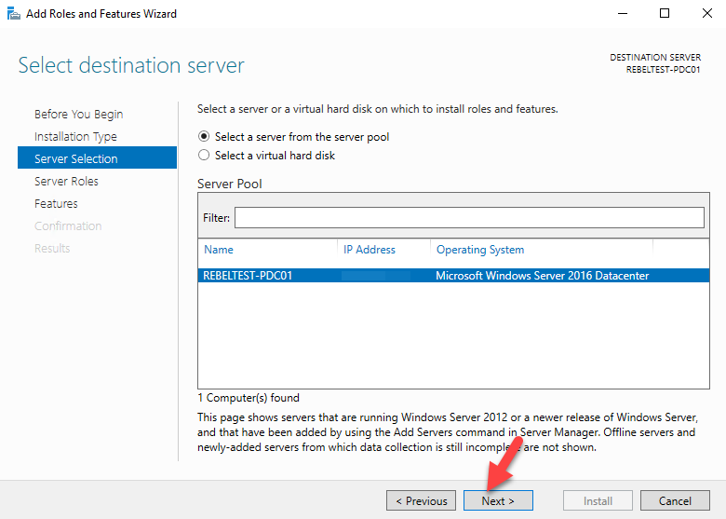](http://www.rebeladmin.com/wp-content/uploads/2016/10/2016AD6.png)

7) In next window from the roles put tick box for **active directory domain services**. Then it will prompt to show you what are the associated features for the role. Click on **add features** to add those. Then click **next** to continue.

[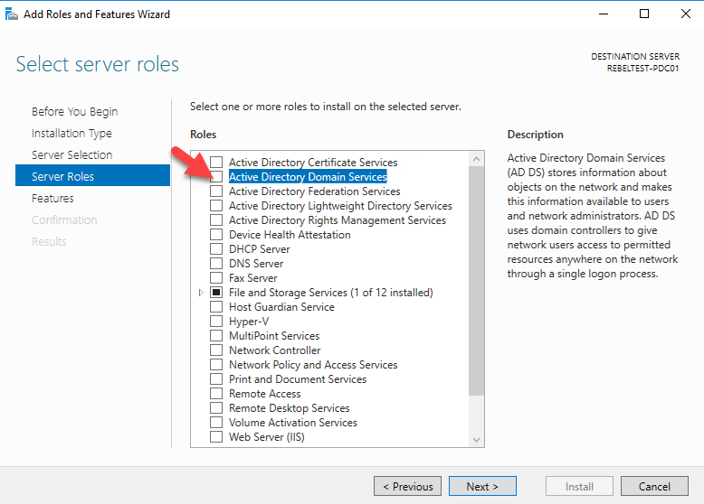](http://www.rebeladmin.com/wp-content/uploads/2016/10/2016AD7.png)

[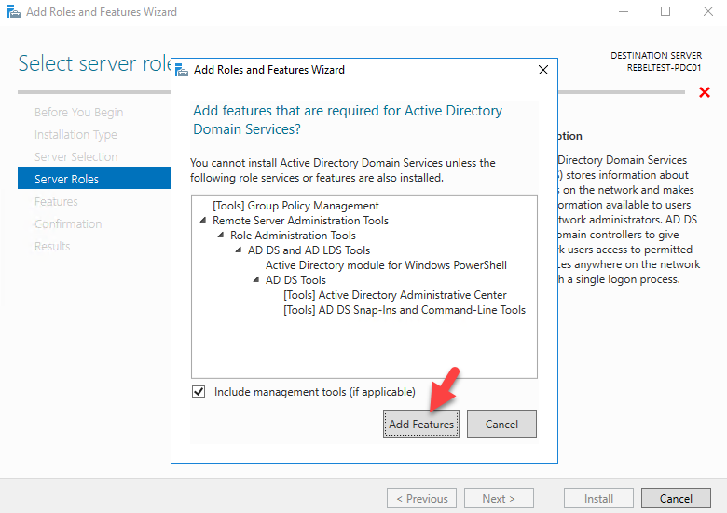](http://www.rebeladmin.com/wp-content/uploads/2016/10/2016AD8.png)

[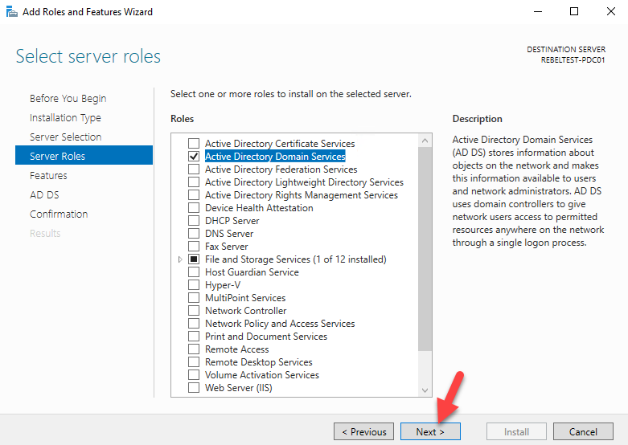](http://www.rebeladmin.com/wp-content/uploads/2016/10/2016AD9.png)

8) The features page, keep it default and click on **next** to proceed.

[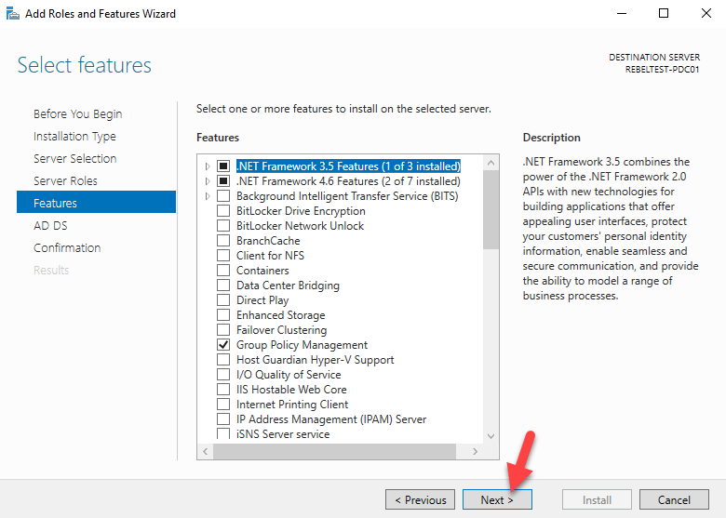](http://www.rebeladmin.com/wp-content/uploads/2016/10/2016AD10.png)

9) In next windows it gives brief description about **AD DS** service. Click **next** to proceed.

[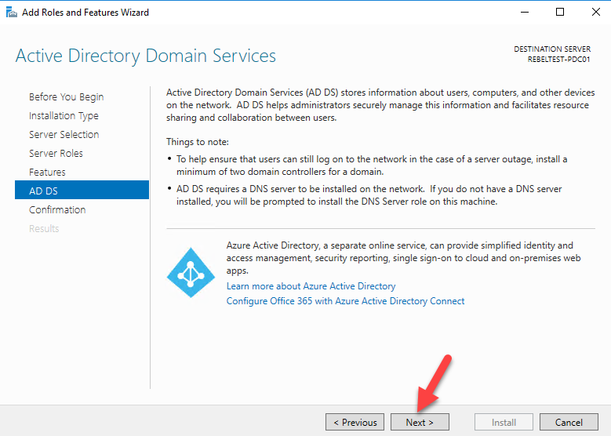](http://www.rebeladmin.com/wp-content/uploads/2016/10/2016AD11.png)

10) Then it will give the confirmation about install, click on **install** to start the role installation process.

[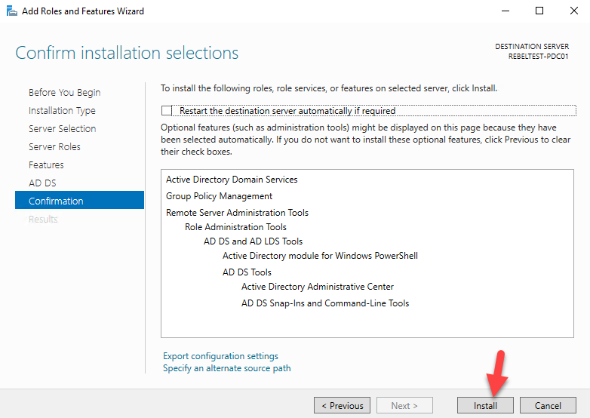](http://www.rebeladmin.com/wp-content/uploads/2016/10/2016AD12.png)

11) Once done, it will start the installation process

[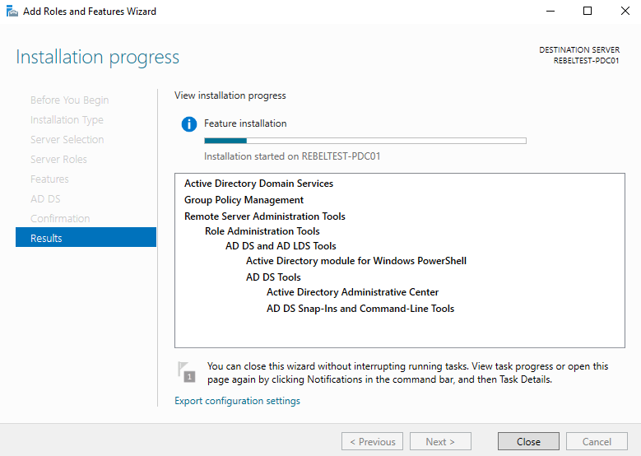](http://www.rebeladmin.com/wp-content/uploads/2016/10/2016AD13.png)

12) Once installation completes, click on option **promote this server to a domain controller.**

[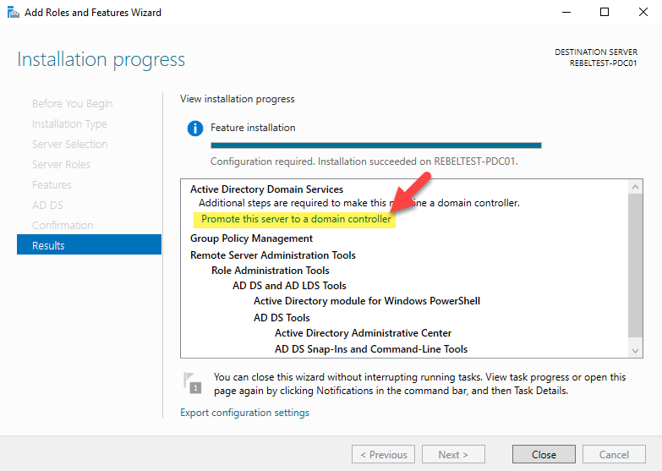](http://www.rebeladmin.com/wp-content/uploads/2016/10/2016AD14.png)

13) Then it will open the active directory configuration wizard. In my demo I am going to setup new forest. But if you adding this to existing domain you can choose relevant option. (I am going to write separate article to cover how you can upgrade from older version of Active Directory). Select the option to add new forest and type FQDN for the domain. Then click **next**.

[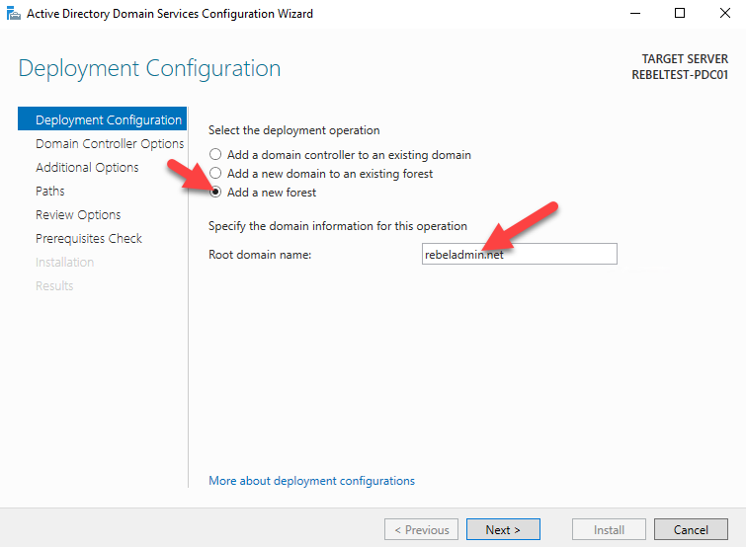](http://www.rebeladmin.com/wp-content/uploads/2016/10/2016AD15.png)

14) In next page you can select the domain and forest functional levels. I am going to set it up with latest. Then type a password for **DSRM**. Then click next

[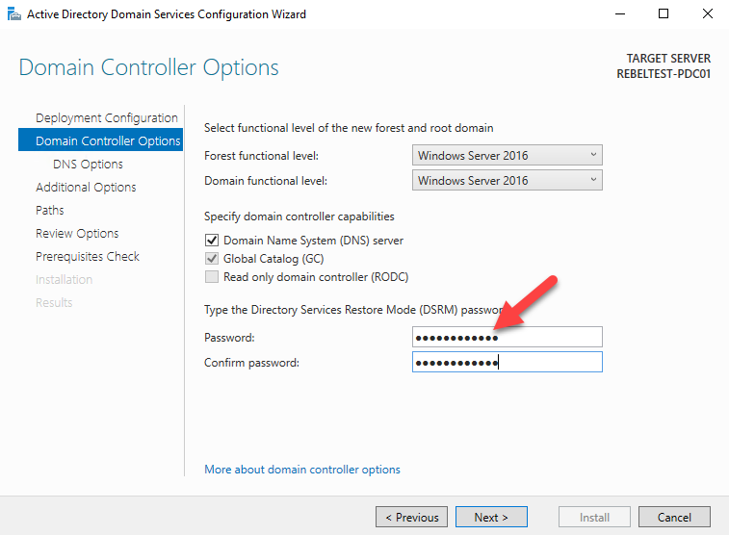](http://www.rebeladmin.com/wp-content/uploads/2016/10/2016AD16.png)

15) For the DNS options, this going to be the first DNS server in new forest. So no need any modifications. Click **next**to proceed.

[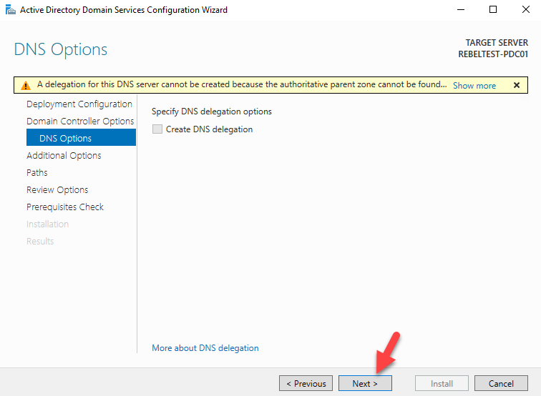](http://www.rebeladmin.com/wp-content/uploads/2016/10/2016AD17.png)

16) For the NETBIOS name keep the default and click **next**

[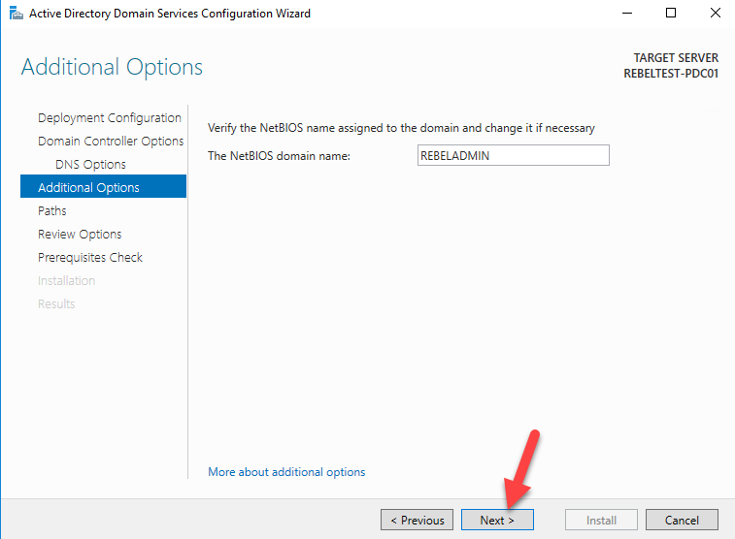](http://www.rebeladmin.com/wp-content/uploads/2016/10/2016AD18.png)

17) Next page is to define the **NTDS, SYSVOL** and **LOG** file folders. You can keep default or define different path for these. In demo I will be keeping default. Once changes are done, click **next** to continue

[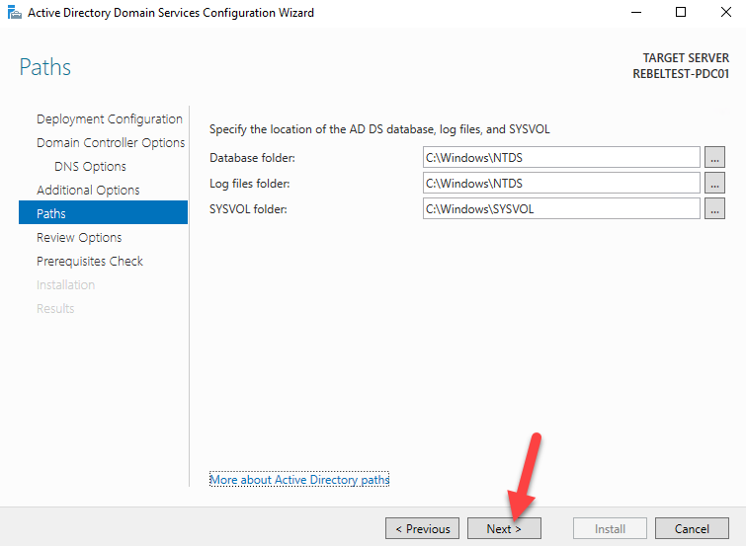](http://www.rebeladmin.com/wp-content/uploads/2016/10/2016AD19.png)

18) Next page will give option to review the configuration changes. If everything okay you can click **next** to proceed or otherwise can go back and change the settings.

[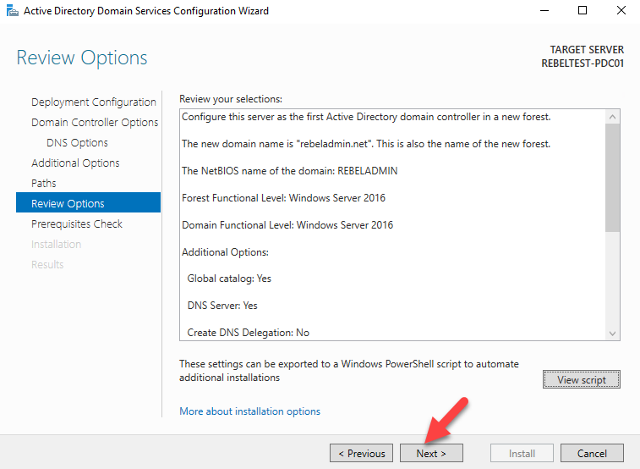](http://www.rebeladmin.com/wp-content/uploads/2016/10/2016AD20.png)

19) In next windows it will do prerequisite check. If it’s all good it will enable option to install. Click on **install** to begin installation process.

[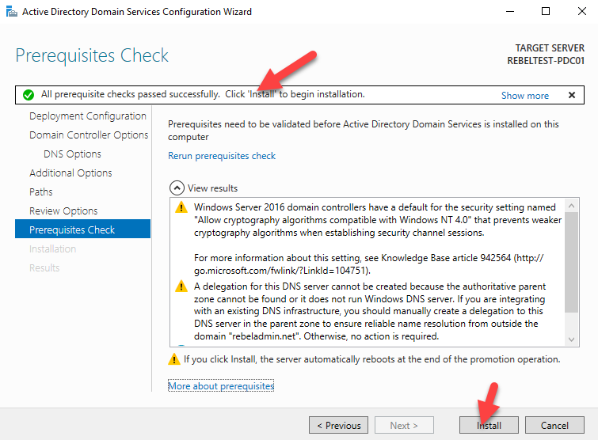](http://www.rebeladmin.com/wp-content/uploads/2016/10/2016AD21.png)

20) Then it will start the installation process.

[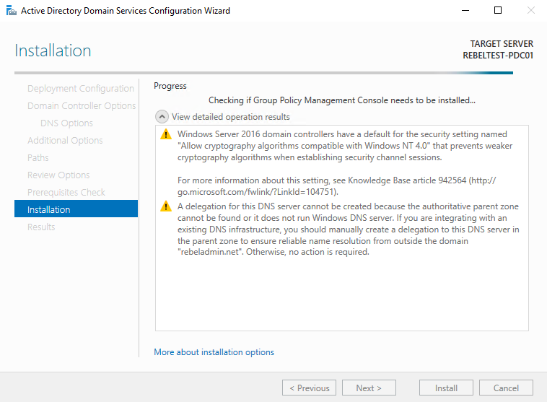](http://www.rebeladmin.com/wp-content/uploads/2016/10/2016AD22.png)

21) After the installation system will restart automatically. Once it comes back log in to the server as domain admin.

[](http://www.rebeladmin.com/wp-content/uploads/2016/10/2016AD23.png)

22) Once log in open the powershell (as administrator) and type **dsac.exe** and press **enter**. It will open up the active directory administrative center. There you can start managing the resources.

[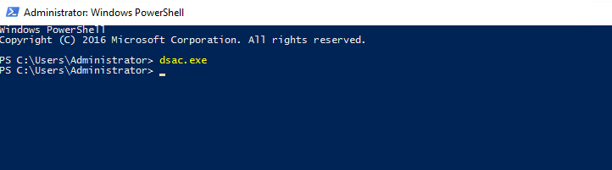](http://www.rebeladmin.com/wp-content/uploads/2016/10/2016AD24.png)

[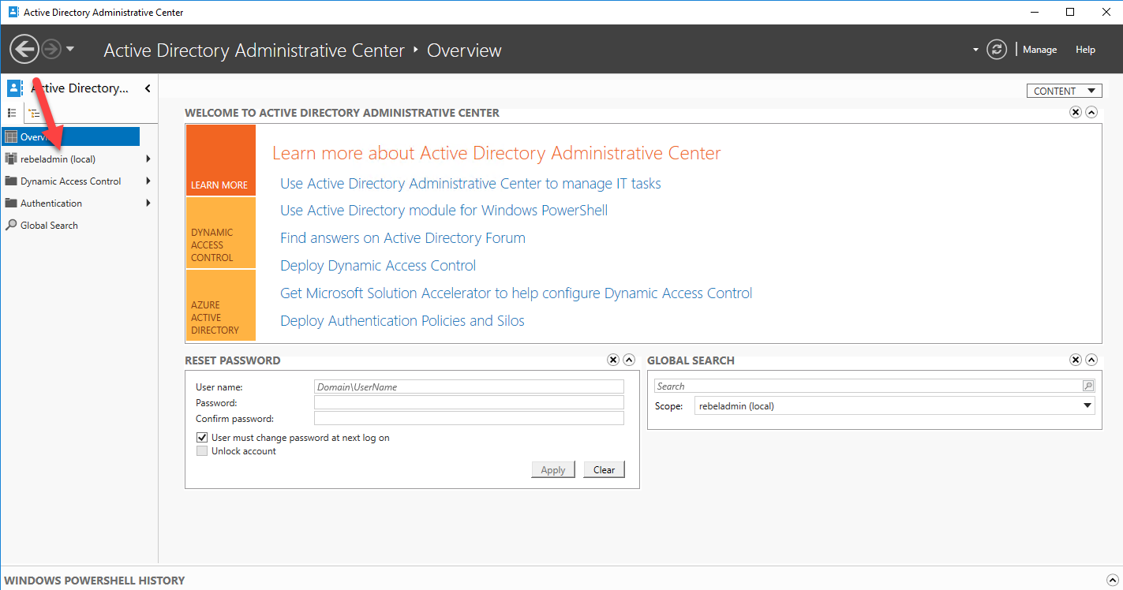](http://www.rebeladmin.com/wp-content/uploads/2016/10/2016AD25.png)

23) Also you can use **Get-ADDomain | fl Name,DomainMode** and **Get-ADForest | fl Name,ForestMode** from powershell to confirm domain and forest functional levels

[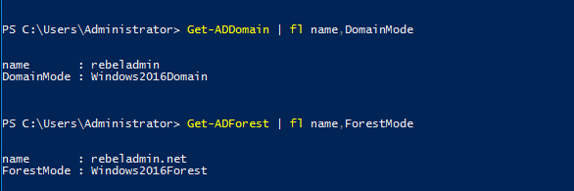](http://www.rebeladmin.com/wp-content/uploads/2016/10/2016AD26.png)

**2.Steps to add User in Active Directory:**

1)Go to server manager->tools->manage users and computers

2)Right click on users ->new->user

3)give user name and insert password for user and select option for password like password never destroy.

4)Click on create.

**3.Create a java spring maven application for login**

1)Import given project as existing maven project.

In login controller you have authentication of user with respect to active directory so first initiate active directory using DirContext ctx = new InitialDirContext(hashtable);

Please follow following for InitialDirContext

https://docs.oracle.com/javase/7/docs/api/javax/naming/ldap/InitialLdapContext.html

Some important variables-

Context.INITIAL_CONTEXT_FACTORY, "com.sun.jndi.ldap.LdapCtxFactory"

Context.PROVIDER_URL, "ldap://localhost:10389"

(here you have to specify server ip address if you are running project on another machine.)

Context.SECURITY_AUTHENTICATION, "simple"

Context.SECURITY_PRINCIPAL, "uid=" + username + ",ou=system"

(username is username,ou=system is domain of your active directory)

Context.SECURITY_CREDENTIALS, password

(password is user password)

Store all these value in hashtable and pass that hashtable to InitialDirContext().

**4. Run java project as run on server.**